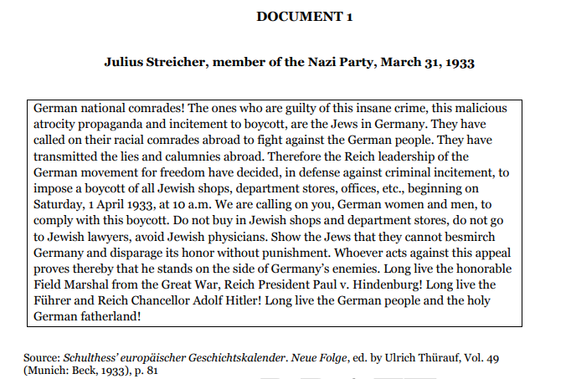

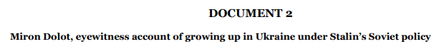

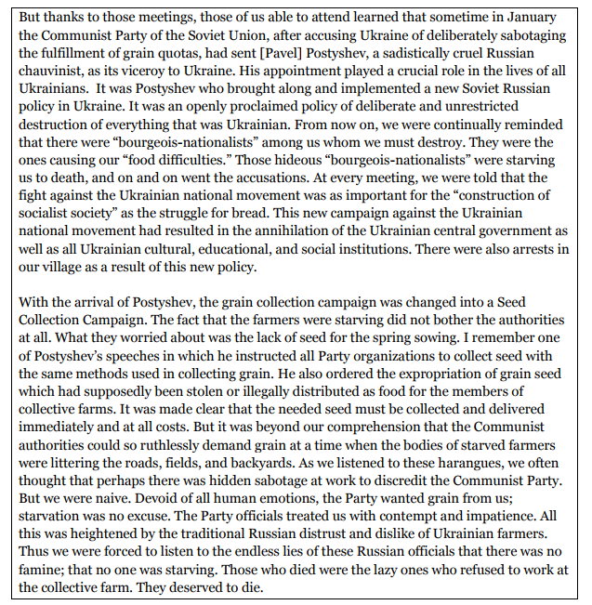

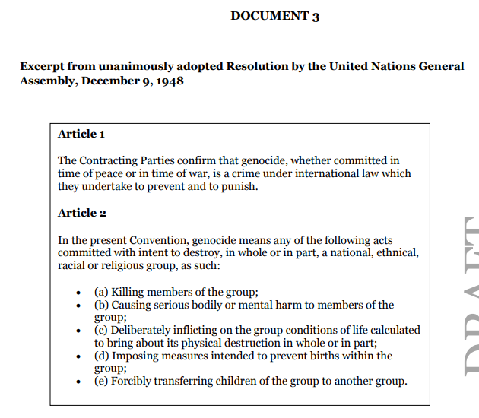

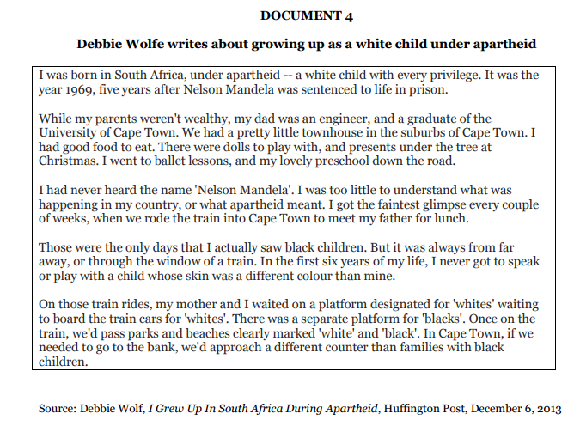

**DOCUMENT 5**

**Tiananmen Square, Beijing, China. June 1989.**